DFS - Template I
Report Issue

As we mentioned in the chapter's description, in most cases, we can also use DFS when using BFS. But there is an important difference: the traversal order.
Different from BFS, the nodes you visit earlier might not be the nodes which are closer to the root node. As a result, the first path you found in DFS might not be the shortest path.
In this article, we will provide you a recursion template of DFS and show you how the stack helps with this process. And then we provide some exercise after this article for you to practice.

Template - Recursion

There are two ways to implement DFS. The first one is to do recursion which you might already be familiar with. Here we provide a template as reference:
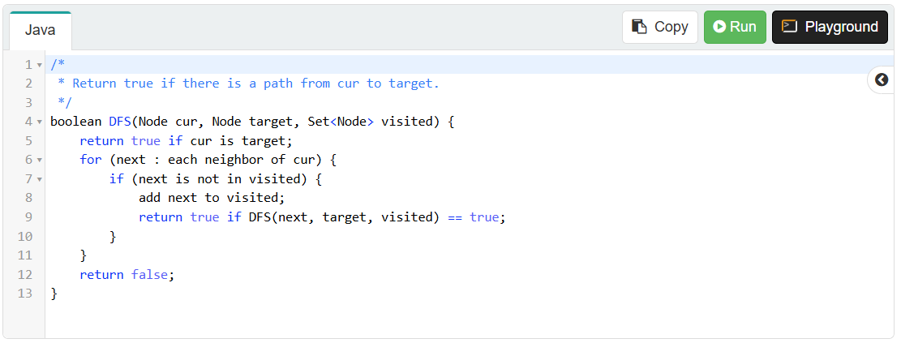
It seems like we don't have to use any stacks when we implement DFS recursively. But actually, we are using the implicit stack provided by the system, also known as the Call Stack.

An Example

Let's take a look at an example. We want to find a path between node 0 and node 3 in the graph below. We also show you the stack's status during each call.
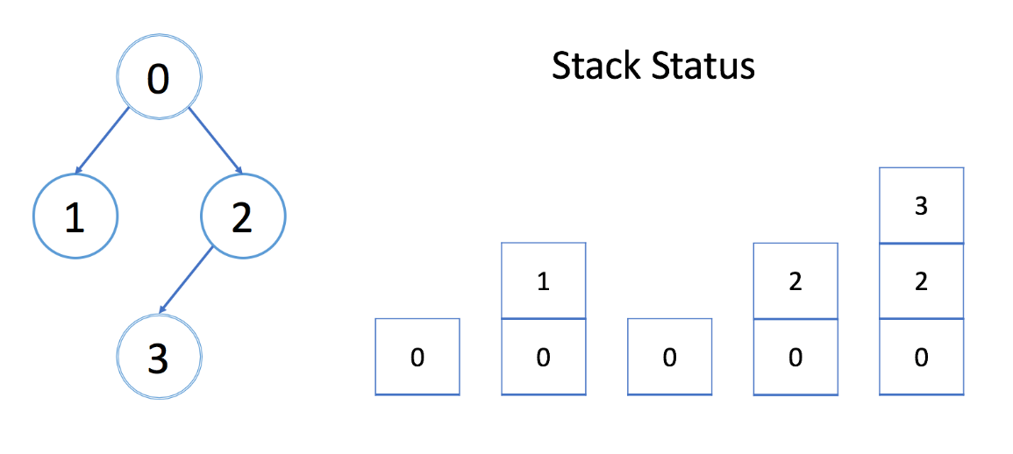
In each stack element, there is an integer cur, an integer target, a reference to array visited and a reference to array edges, which are exactly the parameters we have in the DFS function. We only show cur in the stack above.
Each element costs constant space. And the size of the stack is exactly the depth of DFS. So in the worst case, it costs O(h) to maintain the system stack, where h is the maximum depth of DFS. You should never forget to take the system stack into consideration when calculating the space complexity.
In the template above, we stop when we find the first path.
What if you want to find the shortest path?
Hint: Add one more parameter to indicate the shortest path you have already found.

